AI StudyBuddy — Project Document
Generate High-quality Blog Content Using AI

Project Overview

AI StudyBuddy is an AI-powered learning assistance platform built to streamline and enhance the study process for students. It addresses challenges like scattered notes, time-consuming manual summarization, and a lack of personalized study plans by automating educational resource creation. The platform utilizes a secure Node.js/Express.js backend and integrates directly with Google's Gemini AI API to dynamically generate custom learning materials

Team Members

Team ID: SWTID-2026-7203 Class: III B.Sc Computer Science, Shift - I

Name | Email | NM ID
Ajith Kumar A | www.ajithkumareswari@gmail.com | F83CE37D9242B588004454675F072389
Gowtham R | gowtham90953@gmail.com | 9AD2B557F42DB1588F54B98CE0521185
Hari Haran S | srihariharan27072007@gmail.com | F5CED904C3DD2649BD14BD2ECDE52EF8
Harish B | harishakash977@gmail.com | 7DDCA68C1C7AFFA834F40CBEC7BB83DF

Phase 1

Brainstorming & Ideation Phase

Phase 1: Brainstorming & Ideation Phase

Background

Rahul is a second-year engineering student preparing for multiple semester examinations while simultaneously learning new technical skills for internships and placement opportunities. His study materials are scattered across lecture notes, PDFs, textbooks, online articles, and handwritten notes, making it difficult to organize and revise effectively. Due to the large volume of content and limited preparation time, Rahul often struggles to identify important concepts, create revision notes, and evaluate his understanding before examinations.

Problem

Rahul encounters several challenges during his preparation:

Difficulty understanding lengthy study materials within limited time.

Manual preparation of notes consumes a significant amount of study time.

Creating flashcards and revision questions is repetitive and labor-intensive.

Lack of personalized study plans based on available time and examination schedules.

No centralized platform to securely store AI-generated learning resources.

Difficulty assessing knowledge through self-generated quizzes.

Solution

The AI StudyBuddy backend provides a centralized, AI-powered learning platform that automates several academic tasks through intelligent content generation. The system enables authenticated users to upload or enter study materials and leverage the Google Gemini AI API to generate educational resources automatically.

The backend processes incoming requests through secure RESTful APIs and performs the following operations:

Authenticates users using JWT-based security.

Stores user information and study resources in MongoDB.

Sends study content to the Google Gemini AI model through dedicated AI service modules.

Generates concise summaries for faster revision.

Creates flashcards for active recall learning.

Produces multiple-choice quizzes for self-assessment.

Generates personalized study plans based on user preferences and examination timelines.

Stores generated learning resources for future retrieval and continuous learning.

Usage

Student Usage

Students register and log in to the application before accessing AI-powered learning features. After authentication, they can upload study material or provide textual content and choose the desired AI functionality, such as generating summaries, quizzes, flashcards, or personalized study plans. The generated content can be reviewed immediately and stored for future reference.

Outcome
By integrating artificial intelligence with a secure backend architecture, AI StudyBuddy significantly improves the learning experience for students. Manual preparation time is reduced through automated content generation, allowing students to focus more on understanding concepts rather than organizing study materials.
The implementation of JWT authentication, MongoDB data management, and Google Gemini AI integration ensures that educational resources are generated securely, efficiently, and consistently. The modular backend architecture further supports future enhancements, enabling additional AI-powered learning capabilities to be integrated with minimal architectural changes.

Phase 2

Requirement Analysis Phase

Phase 2: Requirement Analysis Phase

Software Requirements

- Operating System: Windows 10/11, macOS, or Linux (supports cross-platform operations).
- Node.js (v16 or above): Runtime ecosystem running server logic and routing infrastructure.
- npm (v8 or above): Node package manager to control operational dependencies.
- Express.js: Lightweight routing web framework to construct backend RESTful entry points.
- MongoDB: Document NoSQL engine storing users, posts, categories, comments, and analytics metrics.
- Postman: API verification toolkit to assert schema validation responses across administrative route shields.
- Code Editor: Visual Studio Code or similar IDE environment.

Hardware Requirements

- Processor: Intel Core i5 (8th Gen or above) / AMD Ryzen 5 or equivalent.
- RAM: 8 GB minimum (16 GB recommended for concurrent instances of MongoDB, processing layers, and execution nodes).
- Storage: 1 GB of available disk workspace.

Phase 3

Project Design Phase

Phase 3: Project Design Phase

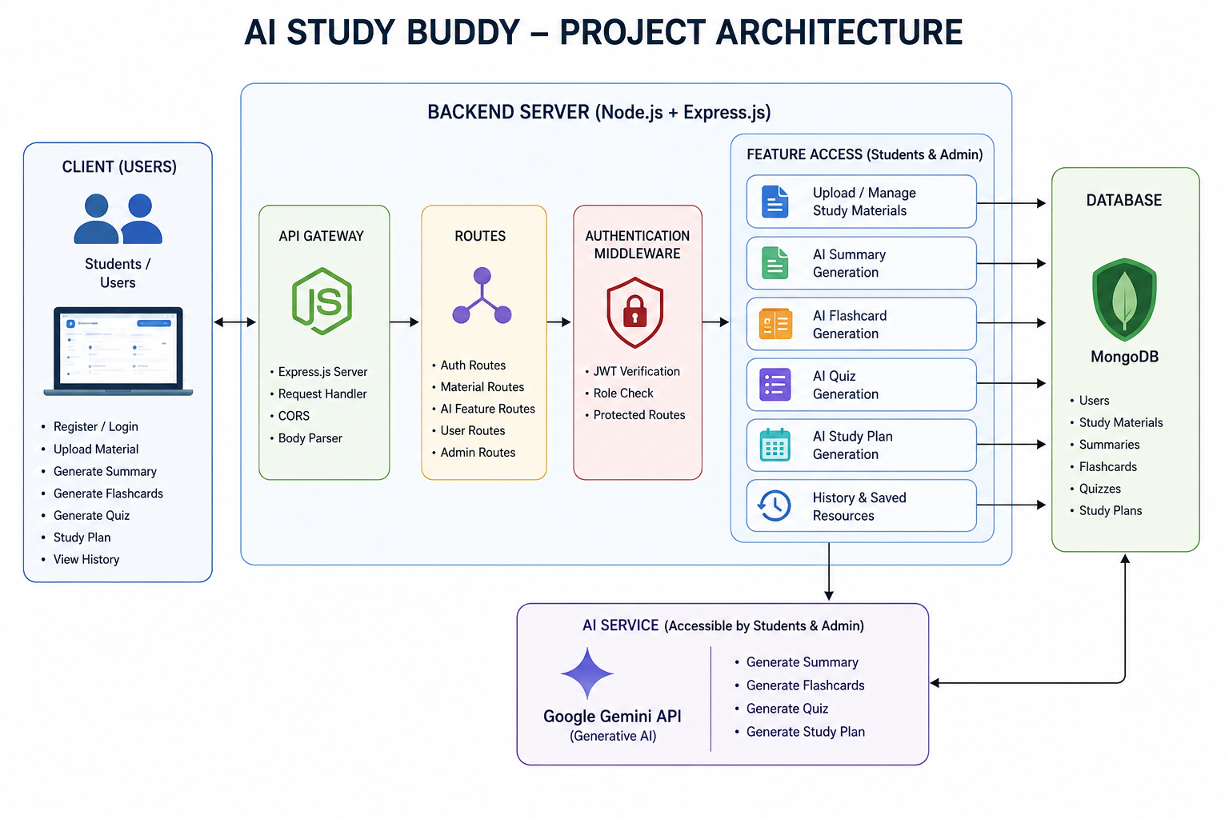

The AI StudyBuddy backend follows a modular RESTful architecture designed to provide secure, scalable, and AI-powered learning services. The system processes client requests through Express.js, validates users using JWT authentication, interacts with the MongoDB database for data storage, and communicates with the Google Gemini AI API to generate intelligent study resources.
The architecture separates authentication, business logic, AI services, and database operations into independent modules, making the application easier to maintain, extend, and debug.
Components Definition
• Client Application: The frontend (React.js) allows users to register, log in, upload study material, and access AI-powered features such as summaries, quizzes, flashcards, and study plans through REST APIs.

• Express Server: The Express.js server receives HTTP requests, handles routing, processes middleware, and sends appropriate responses to the client.

• Authentication Middleware: JWT-based middleware verifies user identity, protects private routes, and ensures that only authenticated users can access AI services and study resources.

• Route Handlers: Routes manage API endpoints related to user authentication, study materials, AI features, and administrative operations.

• AI Service Layer: A dedicated AI service communicates with the Google Gemini API to generate summaries, quizzes, flashcards, and personalized study plans based on the user's study content.

• Database Layer: MongoDB, together with Mongoose ODM, stores user information, uploaded study materials, and AI-generated learning resources securely.

Phase 4
Project Planning Phase

Phase 4: Project Planning Phase

Entity-Relationship (ER) Diagram Description

The AI StudyBuddy backend manages data through interconnected MongoDB collections that store user information, study materials, and AI-generated learning resources. Each entity is linked using logical relationships to ensure efficient data management and retrieval.



User Entity

Stores the details of registered users and administrators.

Attributes:

_id (Primary Key - ObjectId)

name (String, Required)

email (String, Required, Unique)

password (String, Hashed)

role (String - Student/Admin)

createdAt

Study Material Entity

Stores study content uploaded by students for AI processing. Attributes:

_id (Primary Key)

userId (Foreign Key → User)

title

subject

content

createdAt

Summary Entity

Stores AI-generated summaries.

Attributes:

_id (Primary Key)

userId (Foreign Key → User)

materialId (Foreign Key → Study Material)

summary

createdAt

Flashcard Entity

Stores AI-generated flashcards.

Attributes:

_id (Primary Key)

userId (Foreign Key → User)

materialId (Foreign Key → Study Material)

question

answer

createdAt

Quiz Entity

Stores AI-generated quizzes.

Attributes:

_id (Primary Key)

userId (Foreign Key → User)

materialId (Foreign Key → Study Material)

questions

createdAt

6. Study Plan Entity

Stores personalized study plans generated by AI.

Attributes:

_id (Primary Key)

userId (Foreign Key → User)

studyPlan

examDate

createdAt

Key Structural Mappings

User → Study Material (One-to-Many): A user can upload multiple study materials.

Study Material → Summary (One-to-One): Each uploaded material can have one AI-generated summary.

Study Material → Flashcards (One-to-Many): One study material can generate multiple flashcards.

Study Material → Quiz (One-to-One): One study material can generate one quiz containing multiple questions.

User → Study Plan (One-to-Many): A user can generate multiple study plans based on different subjects or examination schedules.

User → AI Resources (One-to-Many): All AI-generated summaries, flashcards, quizzes, and study plans are associated with the user who generated them.

Key Features

The AI StudyBuddy backend provides intelligent learning assistance through secure and scalable REST APIs. The major features of the system are as follows:

- Secure User Authentication: Implements JWT-based authentication with encrypted passwords using bcrypt for secure user access.
- Study Material Management: Allows users to upload and manage study materials that serve as input for AI-powered learning features.
- AI Summary Generation: Generates concise and easy-to-understand summaries from uploaded study content using the Google Gemini API.
- AI Flashcard Generation: Automatically creates flashcards from study materials to improve concept revision and active recall.
- AI Quiz Generation: Produces multiple-choice quizzes based on uploaded content, enabling students to test their knowledge.
- AI Study Plan Generation: Generates personalized study plans according to the user's learning goals and available study time.
- Role-Based Access Control (RBAC): Provides different access privileges for Students and Administrators to ensure secure system management.
- MongoDB Data Storage: Efficiently stores user information, uploaded materials, and AI-generated learning resources using MongoDB.

Roles and Responsibilities

Student

Students are the primary users of the system. They can register, log in securely, upload study materials, and utilize AI-powered features such as summary generation, flashcard creation, quiz generation, and personalized study plans.

Administrator

Administrators manage the overall system and ensure its smooth operation. They monitor registered users, manage user accounts, oversee application usage, maintain system integrity, and ensure that AI-powered services function correctly. Administrators also have permission to perform system-level management tasks and resolve user-related issues.

User Flow

The AI StudyBuddy application begins with the user registering or logging into the system. After successful JWT-based authentication, the user is redirected to the dashboard, where they can upload study materials and access AI-powered features. Based on the uploaded content, the system generates summaries, flashcards, quizzes, or personalized study plans using the Google Gemini API. All generated resources are displayed to the user and can be saved for future reference. Users can also manage their profile and view their previously generated learning resources through the dashboard.

User Flow:
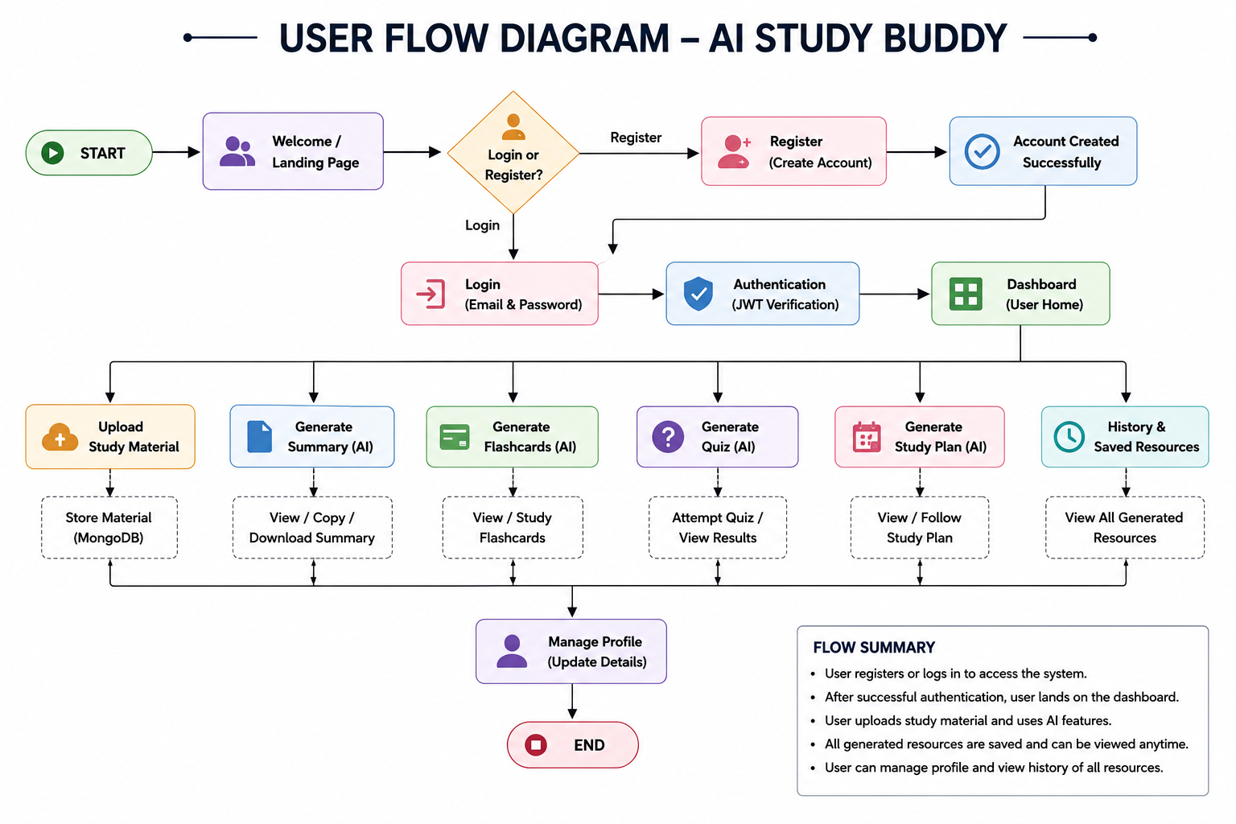

MVC Architecture Pattern
The AI StudyBuddy backend follows the Model-View-Controller (MVC) architecture to organize the application into separate layers, making the code modular, maintainable, and scalable.

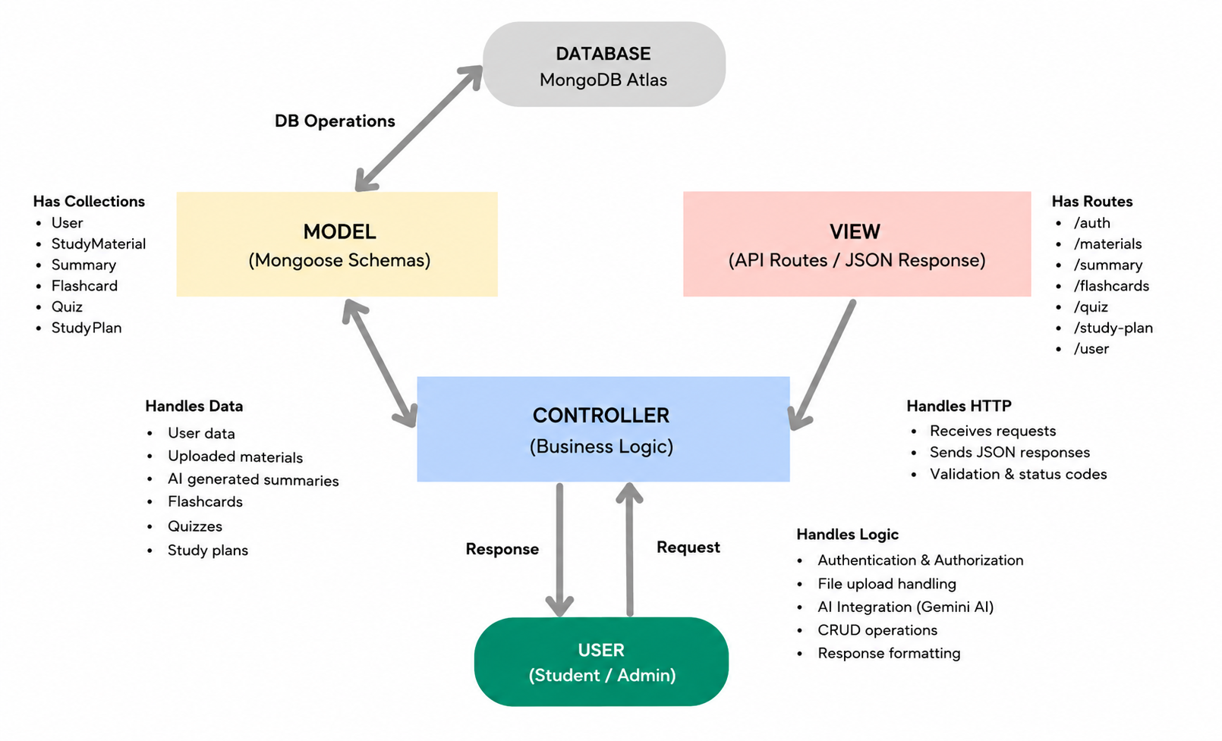

Model Layer (Data Layer)
The Model layer defines the MongoDB collections using Mongoose schemas. It is responsible for managing user information, uploaded study materials, and AI-generated learning resources while ensuring data validation and database interactions.

View Layer (API Response Layer)
Since AI StudyBuddy is a backend REST API, there is no traditional user interface in the View layer. Instead, the API returns structured JSON responses to the React frontend, allowing users to interact with the application through REST endpoints.
Controller Layer (Business Logic)

MVC Benefits
The MVC architecture separates data management, business logic, and client communication into independent components. This improves code readability, simplifies debugging and testing, and allows new features to be integrated without affecting existing modules.

Phase 5
Project Development Phase

Phase 5: Project Development Phase

Covers initializing the Node.js environment, organizing the MVC folder structure in VS Code, and building the Express.js server. It details configuring the MongoDB connection using Mongoose (db.js), defining data schemas (User.js and Blog.js), setting up authentication and error middleware, and integrating Google Gemini AI services.

Creating project folder

- Create a new folder named AI StudyBuddy .
- Open the project folder in Visual Studio Code.
- Initialize the project using Node.js and install the required dependencies.

Project Initialization:

Open the project folder in the VS Code terminal and execute:
npm init -y

Install the required dependencies:
npm install express mongoose bcryptjs jsonwebtoken cors dotenv multer @google/genai

Install Nodemon for development:
npm install --save-dev nodemon

Create the Following Files

- index.js
- .env
- package.json
- .gitignore

Create the Following Folder Structure



Environment Configuration
Create a .env file in the project root and configure the required environment variables.
PORT=5000
MONGO_URI=your_mongodb_connection_string
JWT_SECRET=your_jwt_secret
GEMINI_API_KEY=your_gemini_api_key

Backend Development

The AI Studybuddy Backend Is Developed Using Node.Js, Express.Js, And Mongodb, Following A Modular Architecture. The Application Separates Routing, Controllers, Middleware, Models, And Utility Modules To Improve Code Maintainability And Scalability. The Backend Exposes Secure REST Apis For Authentication, Study Material Management, AI-Powered Content Generation, And Administrative Operations.

Backend Structure



Core System Script Implementations

1. Application Entry Point (index.js)

The index.js file serves as the main entry point of the application. It initializes the Express server, loads environment variables, configures middleware, establishes the MongoDB connection, registers API routes, and starts the server after a successful database connection.



2. Database Connection (src/utils/db.js)

This module establishes a connection between the application and MongoDB using Mongoose. It ensures that the backend communicates with the database before processing any client requests.



Authentication Middleware (src/middleware/auth.js)

The authentication middleware verifies JWT access tokens for protected routes. It authenticates users before granting access to secured APIs and includes role-based authorization to restrict administrative operations.



AI Integration (src/utils/gemini.js)

This utility integrates the backend with the Google Gemini 2.5 Flash API. It sends prompts to the AI model and returns generated responses for summaries, flashcards, quizzes, and study plans.



File Upload Middleware (src/middleware/upload.js)

The upload middleware handles study material uploads and validates incoming files before they are processed by the backend.



Epic 4: Database Configuration

The AI StudyBuddy backend uses MongoDB as its primary NoSQL database and Mongoose ODM for data modeling and schema validation. MongoDB stores user information, uploaded study materials, and AI-generated learning resources in a structured manner. Mongoose simplifies database operations by providing schemas, validation rules, and efficient query handling.

Configure MongoDB

Install Mongoose using the following command:

npm install mongoose

Create Database Connection

Before performing any database operations, establish a connection between the backend and MongoDB using Mongoose. The connection module is initialized during server startup to ensure reliable communication with the database.

Mongoose Schema Definitions

1. User Schema (models/User.js)

The User schema stores authentication and profile information for registered users. It includes fields such as name, email, password, and role. Passwords are securely encrypted before being stored in the database.



2. Study Material Schema (models/Material.js)

The Study Material schema stores the learning content uploaded by users. This content acts as the input for AI-powered features such as summaries, quizzes, flashcards, and study plans.



Database Collections

The AI StudyBuddy database consists of the following collections:

Users – Stores user account and authentication details.

Study Materials – Stores uploaded learning materials.

API Route Interface Endpoints

The backend exposes RESTful APIs to interact with the database and AI services.

1. Authentication APIs

Handles user registration, login, JWT authentication, and protected route access.

2. Study Material APIs

Allows users to upload, retrieve, update, and manage study materials.

3. AI Feature APIs Provides endpoints for:

AI Summary Generation

AI Flashcard Generation

AI Quiz Generation

AI Study Plan Generation

4.Administrative APIs

Provides administrator-only endpoints for managing users and monitoring system activities.

Epic 5: Project Execution

The AI StudyBuddy backend can be executed locally using Node.js. Before running the application, ensure that MongoDB is running and the required environment variables are configured correctly. The backend exposes REST APIs that can be tested using Postman or Thunder Client.

Running the Backend Server

Install all required dependencies:

npm install

Start the development server:

npm start

After successful execution, the server connects to MongoDB and starts listening for incoming API requests.

GitHub: Code Link

Phase 6

Project Testing Phase

Phase 6: Project API Testing

Focuses on running the backend server and verifying all REST API endpoints using Postman or Thunder Client. It validates request payloads, JWT Bearer authorization, HTTP status codes (200 OK, 201 Created), and JSON responses across user registration, login, manual blog creation/fetching, AI blog generation, and AI content summarization.

User Registration:

HTTP Method: POST
Endpoint: /api/auth/register



User Login:

HTTP Method: POST
Endpoint: /api/auth/login



Create Blog:

HTTP Method: POST
Endpoint: /api/materials/upload



Fetch Blogs:

HTTP Method: POST
Endpoint: /api/materials/:id/summarize

Generate AI Blog:

HTTP Method: POST
Endpoint: /api/ai/flashcards



Summarize Blogs:

HTTP Method: POST
Endpoint: /api/ai/quiz


HTTP Method: POST
Endpoint: /api/ai/study-plan



Phase 7
Project Documentation Phase

Phase 7: Project Documentation Phase

Phase | Covers
Brainstorming & Ideation Phase | Study management problem & proposed AI StudyBuddy solution
Requirement Analysis Phase | Software & hardware requirements
Project Design Phase | Backend layered architecture & AI service integration
Project Planning Phase | ER diagram, user flow, roles & MVC pattern
Project Development Phase | Backend setup, MongoDB connection, schemas & core code
Project Testing Phase | API endpoint testing & validation
Project Documentation Phase | Code structure, schemas & endpoints compilation
Project Demonstration Phase | Working video demo & live API execution

Project Core Highlights
- Problem & Requirements — Explains the study management and content processing challenges faced by students, the proposed AI StudyBuddy solution, role-based usage (Student, Teacher/Mentor, Admin), and the required software and hardware setup.

- Design & Architecture — Describes the layered backend architecture, Entity-Relationship (ER) database structure, MVC pattern (Model-View-Controller), user access roles, and system workflows.

- Development & Implementation — Covers VS Code project setup, Node.js/Express server configuration, MongoDB/Mongoose connection and schemas (User, Note, Quiz), JWT-based authentication, routing, and Google Gemini AI API integration.

- Testing & Demonstration — Features end-to-end API testing using Postman/Thunder Client for authentication, study note management, AI text summarization, and automated quiz/flashcard generation, along with a live execution setup.

Phase 8
Project Demonstration Phase

Phase 8: Project Demonstration Phase

The demonstration video provides a complete technical walkthrough of the AI StudyBuddy API, covering the codebase architecture, server initialization, and live endpoint verification.
- Project File Explanation — Walks through the VS Code workspace and src directory following the MVC pattern, explaining the database setup (config/db.js), data schemas (models), business logic (controllers), API route mappings (routes), JWT security and error handling (middleware), and the Google Gemini AI integration (services/geminiService.js).
- Backend Execution — Demonstrates configuring environment variables (.env), initializing the Express application (app.js and server.js), and starting the local backend server via npm start alongside an active MongoDB connection.
- API Endpoint Testing — Uses Thunder Client / Postman to showcase the exact request payloads, authorization headers, HTTP status codes, and JSON responses across all core endpoints:
  - User Registration (POST /api/auth/register): Sends a raw JSON body containing name, email, and password. The server hashes the password, creates the user record in MongoDB, and returns a 201 Created status with the generated user ID and profile details.
  - User Login (POST /api/auth/login): Submits the registered email and password credentials. The backend validates the account and returns a 200 OK status along with a signed, stateless JWT token used for accessing protected routes.
  - Create Study Note (POST /api/notes): Uploads study material content with a title and subject under the authenticated user's account, returning a 201 Created response.
  - Get Study Notes (GET /api/notes): Fetches all notes associated with the logged-in user with a 200 OK response.

  - AI Summarize Notes (POST /api/ai/summarize-notes): Sends study content to the Google Gemini AI service to generate a concise summary and updates the note record.
  - AI Generate Quiz (POST /api/ai/generate-quiz): Processes note content through Gemini AI to dynamically extract multiple-choice questions or flashcards for self-assessment.
  - AI Generate Study Plan (POST /api/ai/study-plan): Accepts target subjects, exam dates, and available hours to synthesize a personalized revision timetable and returns a 201 Created response.

• Create Note (POST /api/notes): Passes the JWT Bearer token in the Authorization header alongside a JSON payload with title, content, and subject. The server links the study note to the logged-in student and returns a 201 Created status with the saved note document and timestamps.

• Fetch Notes (POST /api/notes): Queries the database for all stored study notes belonging to the authenticated user and returns a 200 OK status with a JSON array of note documents, automatically populated with the student's ID, name, and email.

• Generate AI Flashcards (POST /api/ai/flashcards): Sends a JSON prompt containing a subject topic or raw study content. The controller calls the Gemini AI service to synthesize key concept flashcards, saves them directly to MongoDB under the authenticated user, and returns a 201 Created status.

• Summarize Notes (POST /api/ai/summarize): Submits lengthy lecture text or study material in the request body. The AI engine condenses the input and returns a 200 OK status with a concise summary abstract and key takeaways.

• Generate AI Quiz (POST /api/ai/generate-quiz): Transmits study material content or topic parameters in a JSON payload. The backend processes the input using the Gemini AI service to dynamically generate multiple-choice questions, correct answers, and explanations, saves the quiz record to MongoDB under the user account, and responds with a 201 Created status.

• Generate Study Plan (POST /api/ai/study-plan): Accepts exam dates, target subjects, and daily study hours within the request body. The AI engine generates a structured, personalized revision timetable with daily tasks and milestones, stores the schedule in the database, and returns a 201 Created status

Demo Video: Demo Video Link

